# Chapter 4: System Design

### Chapter 4

* 1. **INTRODUCTION**

#### SYSTEM DESIGN

In this chapter we will cover all the relevant designs and tables related to the project of Job Explorer system. Its architecture, detailed design (use case diagrams, detail use case, activity diagrams, component diagrams), and database designs (ERD).

##### ARCHITECTURAL DESIGN

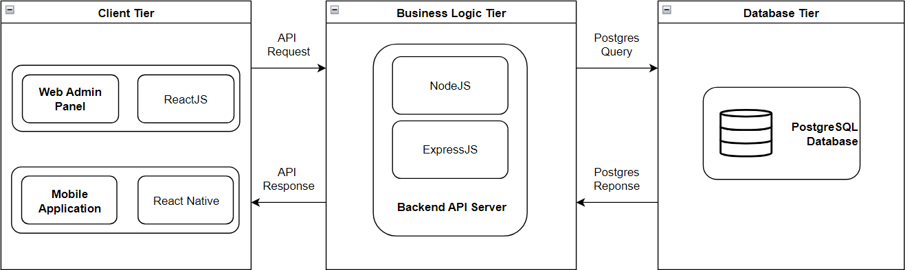

**Fig 4.1: Architectural Diagram**

##### DETAILED DESIGN

###### Use Case Diagrams

* + - 1. User Registration and Authentication Use Case Diagram

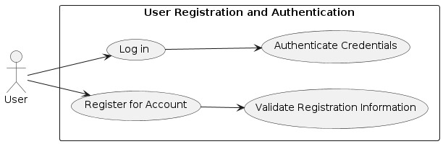

**Fig 4.2: User****Registration****and****Authentication Use Case Diagram**

* + - 1. Recommendation and Personalization Use Case Diagram

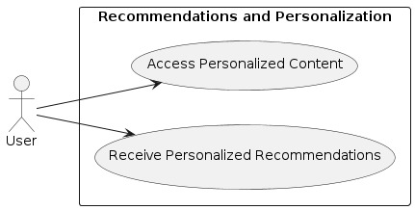

**Fig 4.3: Recommendation****and****Personalization Use Case Diagrams**

* + - 1. Profile Management Use Case Diagram

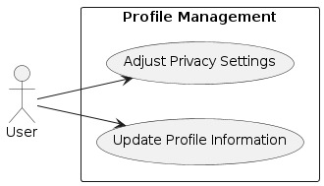

**Fig 4.4: profile Management Use Case Diagram**

* + - 1. Job Listing and posting Use Case Diagram

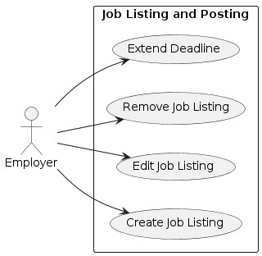

**Fig 4.5: job Listing and posting Use Case Diagram**

* + - 1. Job search and Filtering Use Case Diagram

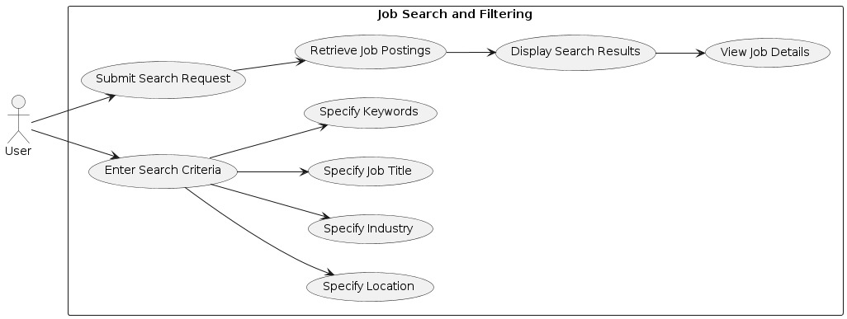

**Fig 4.6:job search and Filtering Use Case Diagram**

* + - 1. Communication and Messaging Use Case Diagram

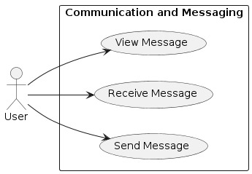

**Fig 4.7: communication and Messaging Use Case Diagram**

* + - 1. Application Management Use Case Diagram

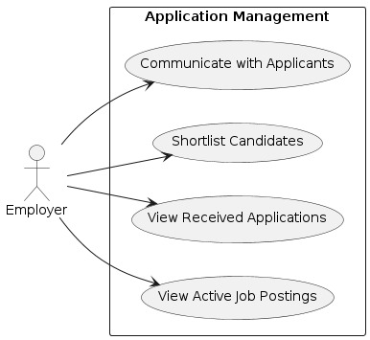

**Fig 4.8: Application Management Use Case Diagram**

* + - 1. Application Submission and tracking Use Case Diagram

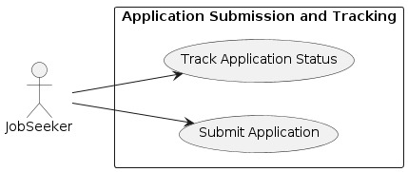

**Fig 4.9: Application Submission and tracking Use Case Diagram**